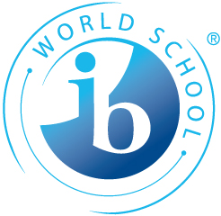
Application for the 2 year IB Diploma Programme
2021-23 - Deadline: March 15th
Application is possible after this date – please contact us.

PERSONAL DATA
Surname/Last name |  | Nationality (Passport)
First name (s) |  | CPR-number (or date of birth)
Address (street)

Zip code | Town | Country
Phone | E-mail
Present school and grade
(Minimum ten years of schooling is required)

PARENT(S)/GUARDIAN
Surname/Last name

Address (street)

Zip code | Town | Country
Phone | E-mail

LANGUAGE Choices (choose one in each category)
Best / native language:  - if you are bilingual, you may tick several boxes | Danish | English  Other: __________________
1st foreign language | Danish | English

BOARDING ACCOMMODATION
I also apply for boarding accommodation and have filled in and attached the separate application form

RESIDENCE PERMIT (Only non Danish citizens)
I have a residence permit from the Danish Immigration Authorities

I do not have a residence permit from the Danish Immigration Authorities. The status for my application is:

IBO REGULATIONS AND PRINCIPLES
I have read the General Regulations for the Diploma Programme, as stated in the official IBO document at www.eucsyd.dk
and with my signature below, I accept these.
SUBJECT CHOICES IB @ EUC Syd 2021

Name: _____________________________________________

Group 1 | SL | HL
English Language & Literature
Danish A Literature
Self taught language (please specify which language)
Group 2 | SL | HL
English B | Not available
Danish B | Not available
Spanish ab initio |  | Not available
Group 3 | SL | HL
History
Psychology
Group 4 | SL | HL
Chemistry
Physics
Biology
Group 5 | SL | HL
Mathematics: Analysis and approaches
Group 6 | SL | 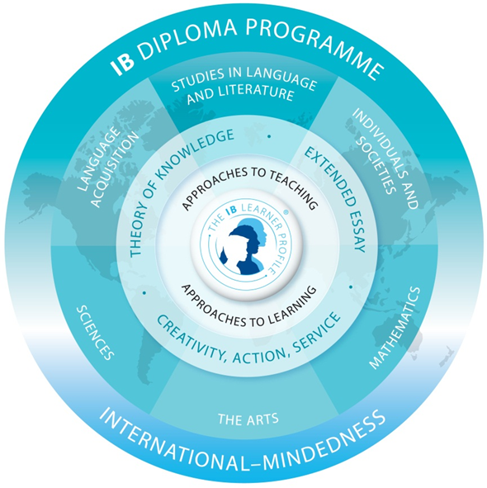  HL
Visual Arts
Core (compulsory) | SL | HL
Theory of Knowledge
CAS (Creativity, Activity, Service)
Extended essay

Please prioritize subjects in groups with more than one subject
offered.
Please be aware that courses offered are subject to change.

ENCLOSED DOCUMENTS: Please tick off the boxes
A photocopy of applicant’s passport (required for non Danish citizens only)
A photocopy of applicant’s Danish “sygesikringsbevis” (if available)
Latest report card (required – if the report card is not in Danish, English, German, French or Spanish,
attach a translated version, translated by an authorised translator)
Reference/statement from present school confirming your place and level (required). An actual reference is preferred.
Personal statement: “Why do I want to study the Pre-IB and IB-programme” max. one page (required)
Other (optional):

SIGNATURES and DATE
Date Applicant | Date Parent/guardian

This application, complete with all necessary documents, to be sent to:

EUC Syd
Teknisk Gymnasium Sønderjylland
Hilmar Finsens Gade 18
DK - 6400 Sønderborg
Att: IB Office

If you have any questions please contact us:

IB Office
EUC Syd, Teknisk Gymnasium Sønderjylland
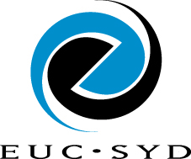
Hilmar Finsens Gade 18
6400 Sønderborg
Denmark

Phone: +45 7412 4242
Fax: +45 7412 4200
Web: www.eucsyd.dk
E-mail: eucsyd@eucsyd.dk

